Assignment 11- Integrated Analysis
Course: 6380.003
Name: Anamika Das
Net ID: axd240045

1. 891 obj, 11 variables. But console output is: 891 12
2. 29.69912
3.
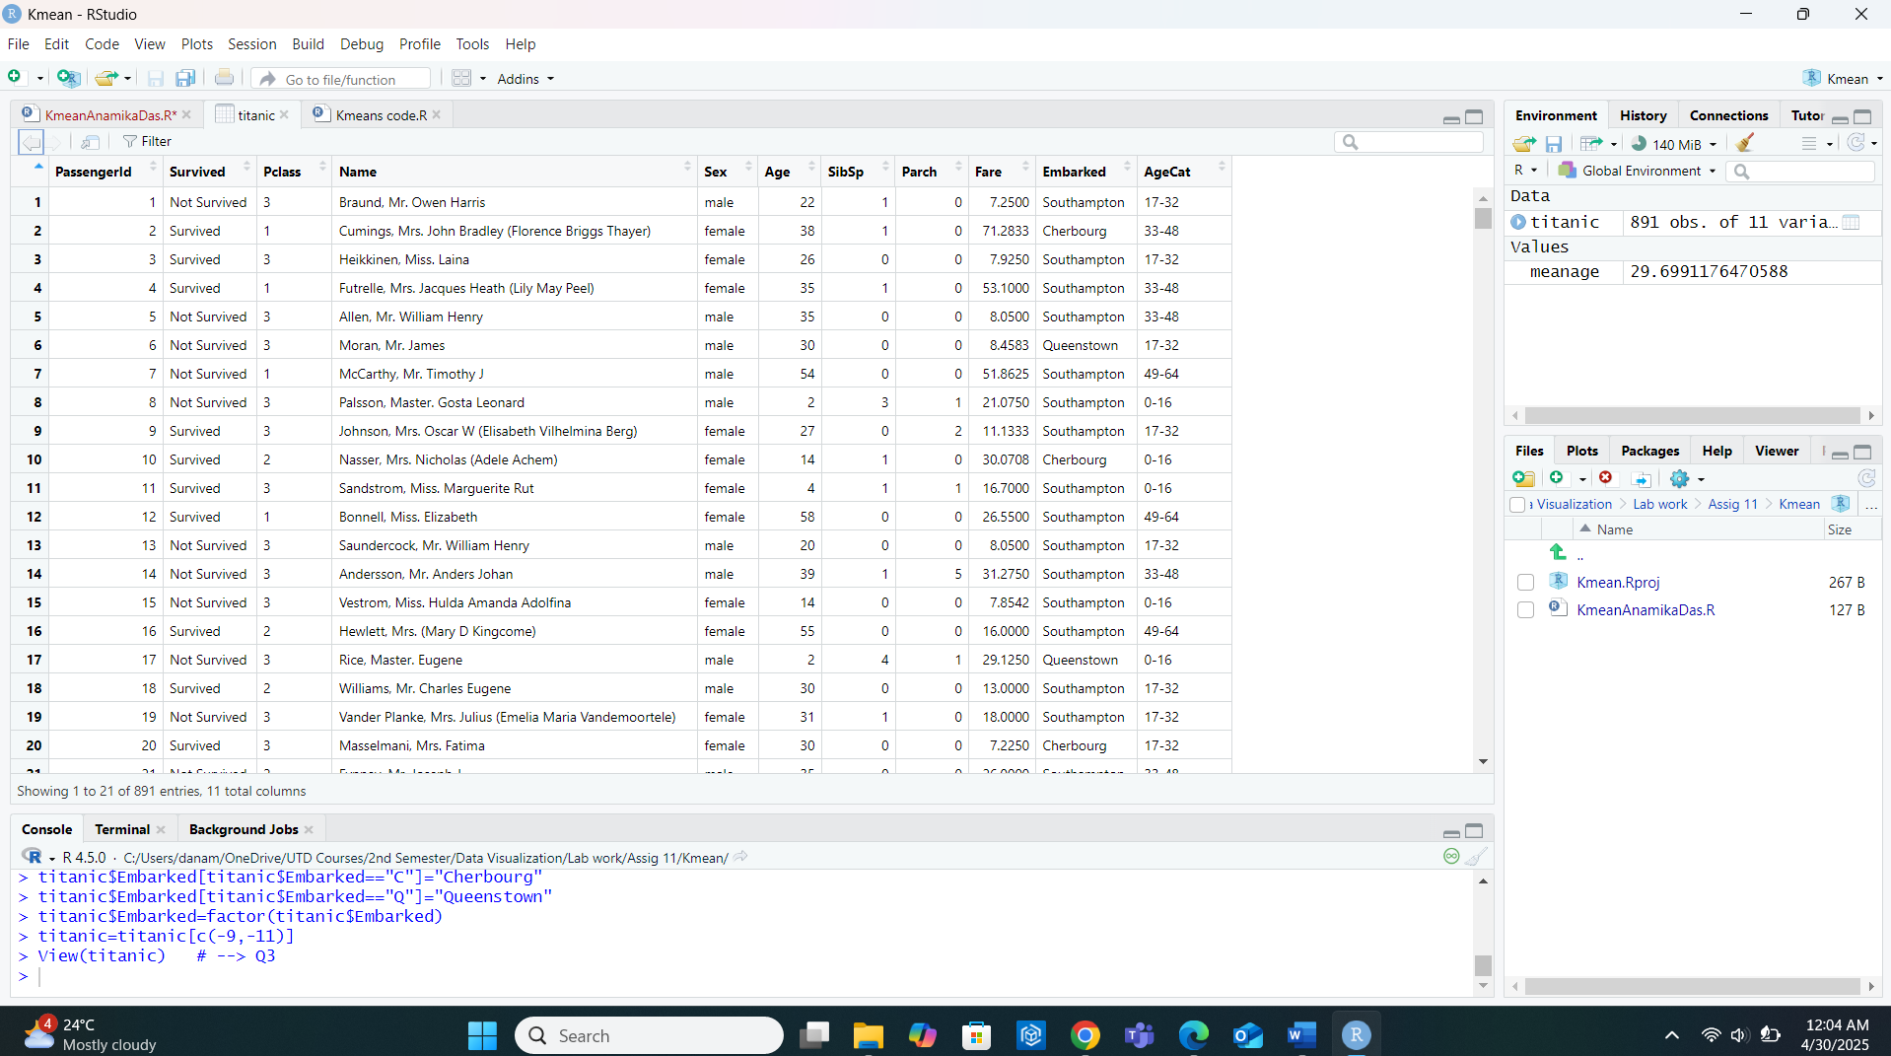
4.
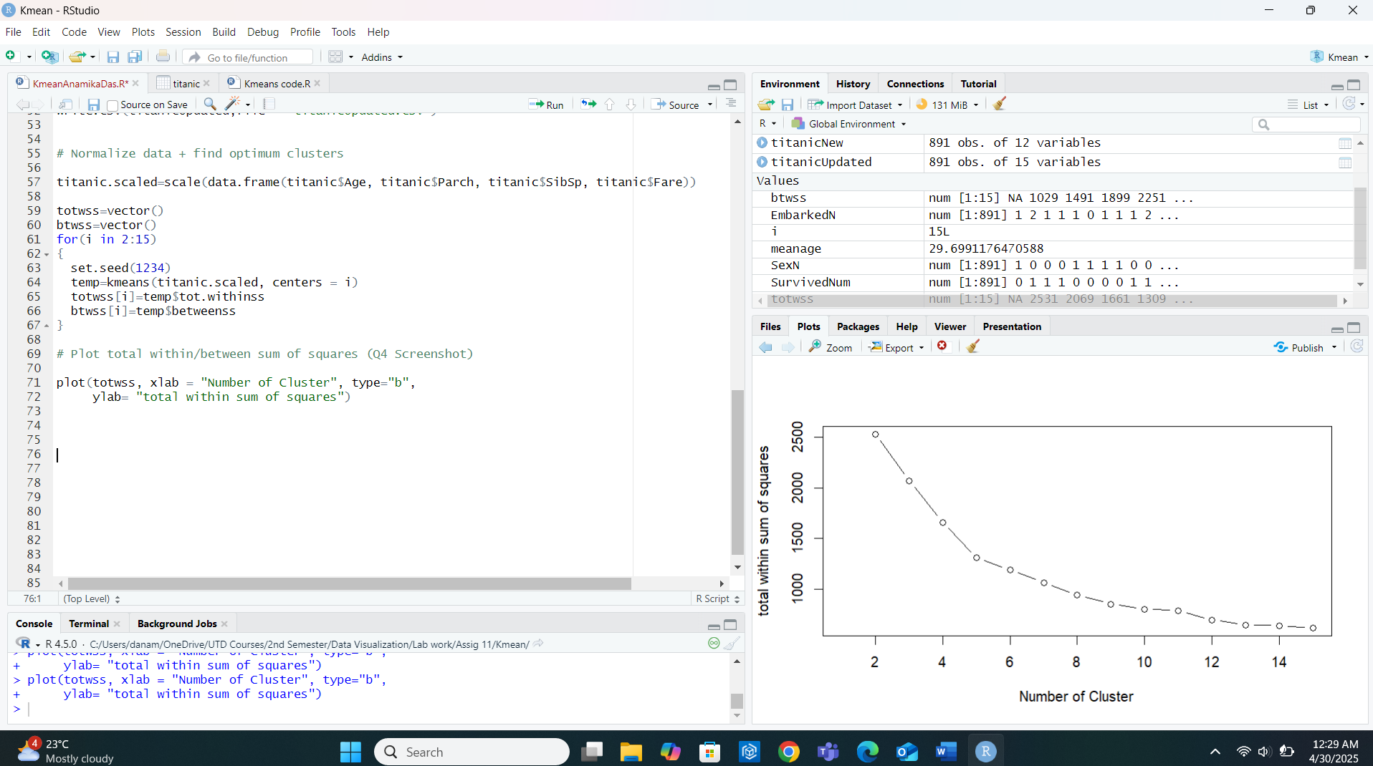
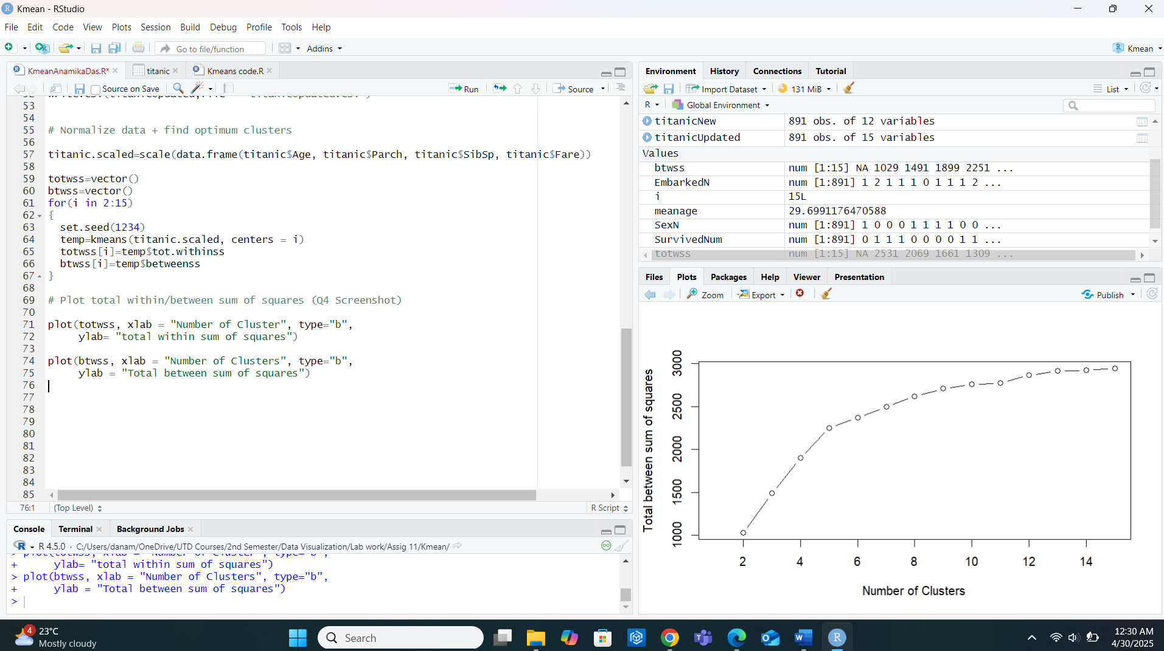

5. Desired number of clusters: 5
6.


7.
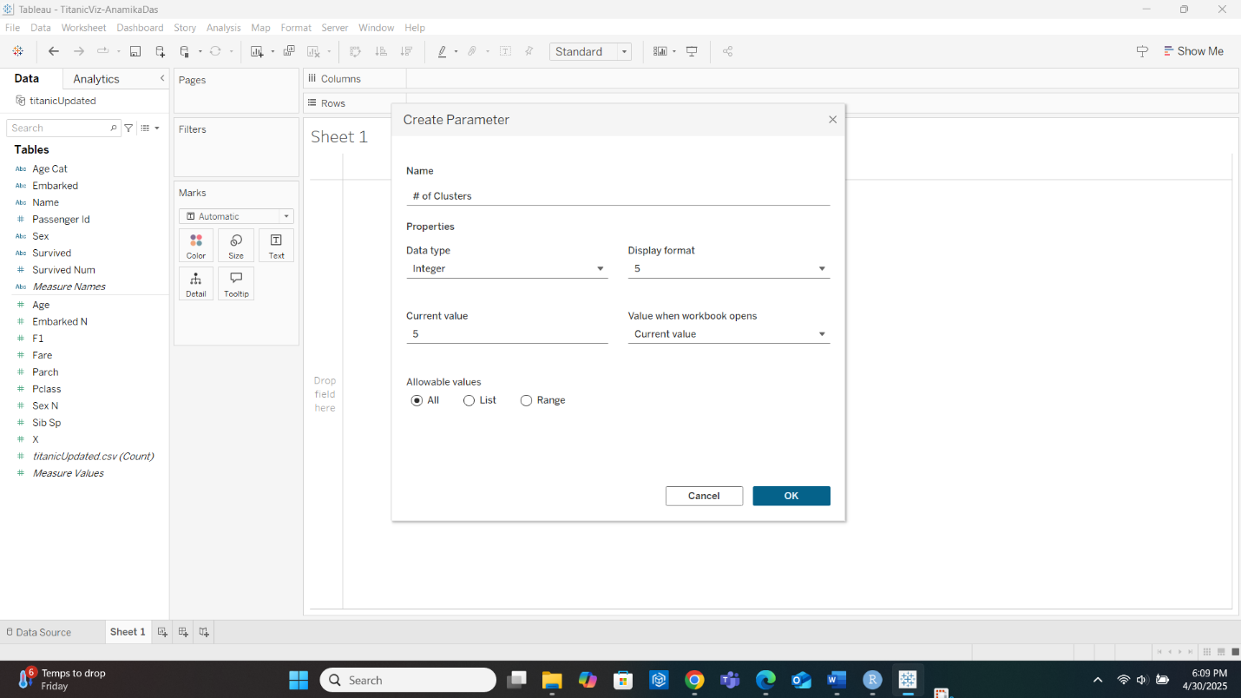

8.
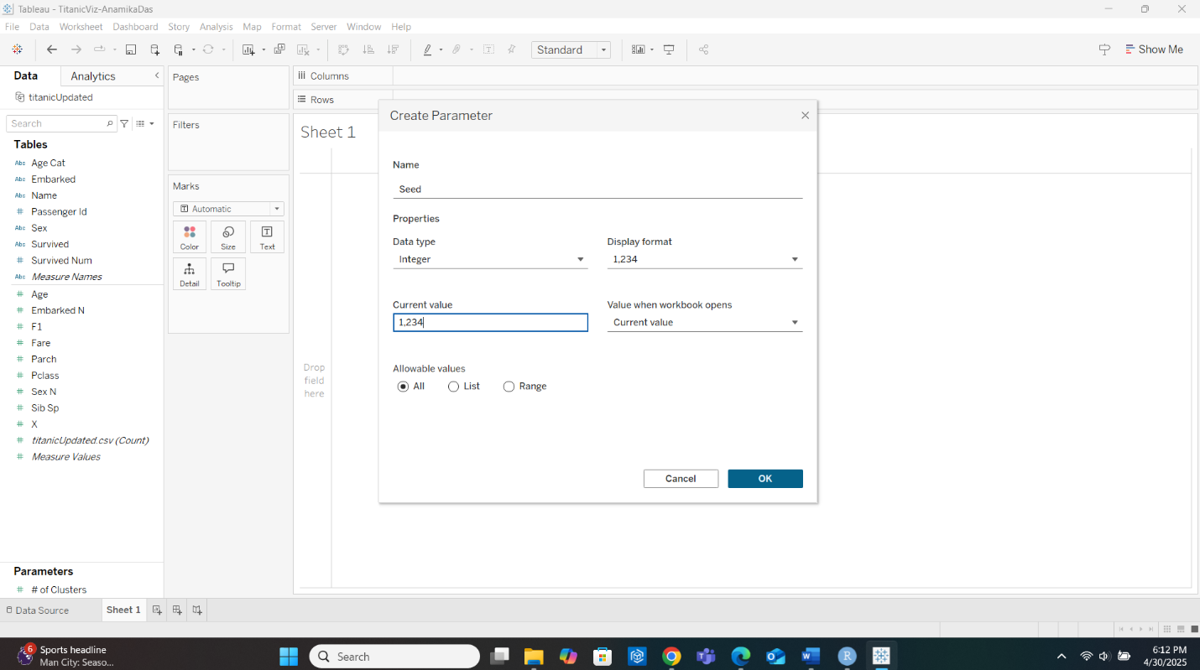

9.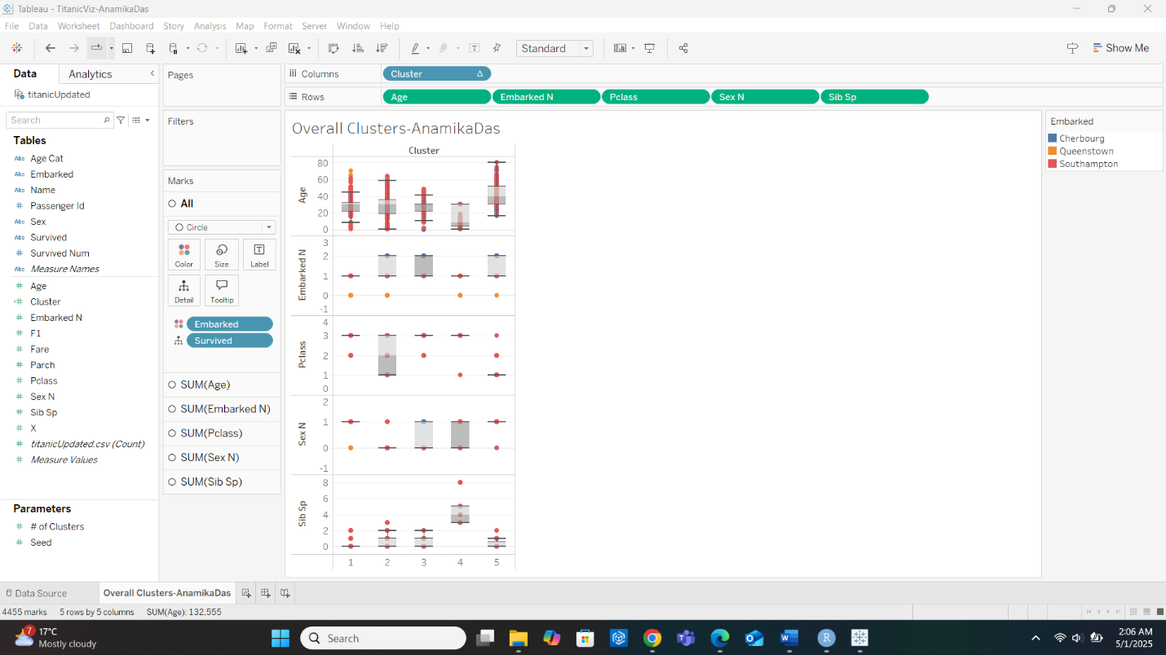

10. Cluster 1 is predominantly composed of passengers with the following characteristics:
- Age: Mostly younger passengers
- Embarked N: Majority embarked from Southampton (red dots dominate)
- Pclass: Mostly 3rd class passengers (lower Pclass value dominates)
- SexN: Dominantly male (SexN = 1)
- SibSp: Majority have 0 siblings/spouses onboard (SibSp = 0)
Thus, Cluster 1 primarily represents young 3rd-class males from Southampton traveling alone.

11. Cluster 4 is predominantly composed of passengers with the following characteristics:
- Age: Mid-range passengers (the box plot median ~35 years)
- Embarked N: Majority embarked from Southampton (red dots dominate again)
- Pclass: Mostly 1st class passengers (higher Pclass value)
- SexN: Dominantly female (SexN = 0)
- SibSp: Passengers mainly have 0 or 1 siblings/spouses onboard
Thus, Cluster 4 primarily represents 1st class females from Southampton, with few or no siblings.

12.
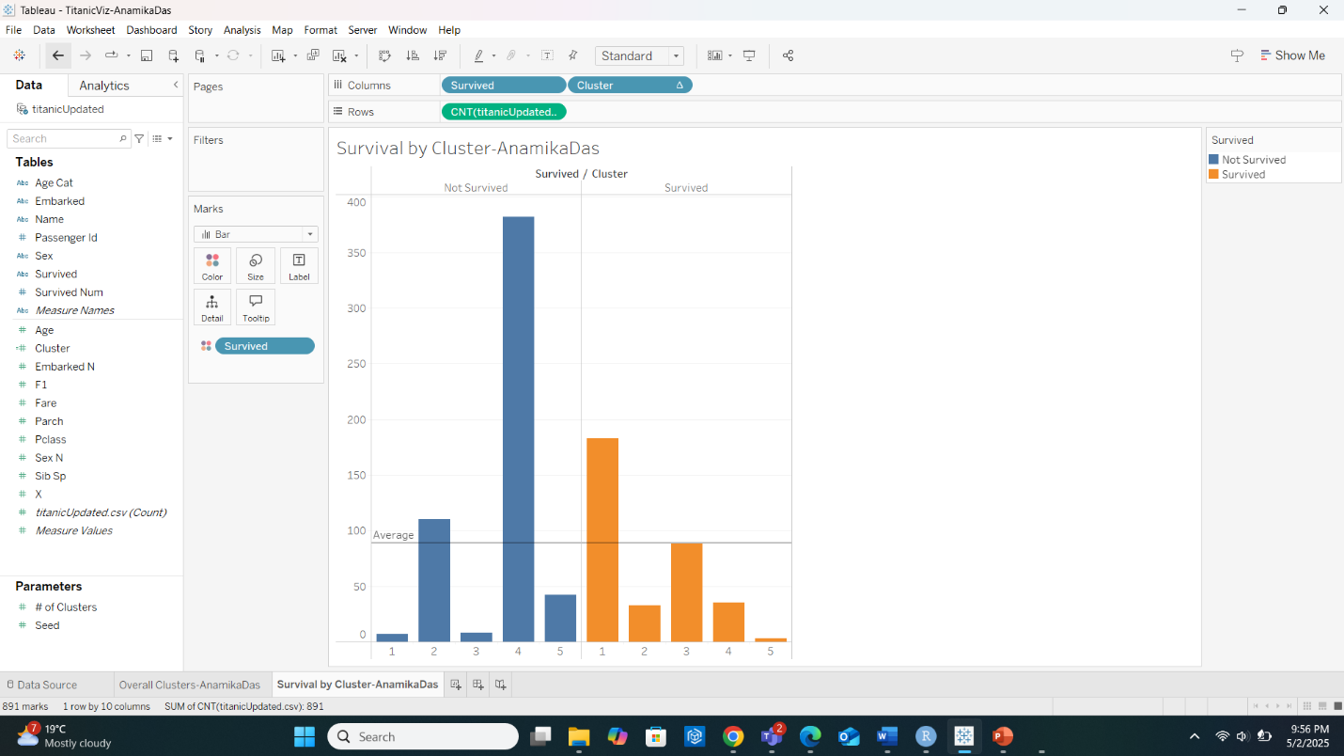

13. clusters 1 and 3.

14.
 | <Cluster 1> | <Cluster 3>
Ideal Gender
Ideal Passenger Class
Ideal Age Category
Ideal Embarked point
Ideal number of siblings

15.
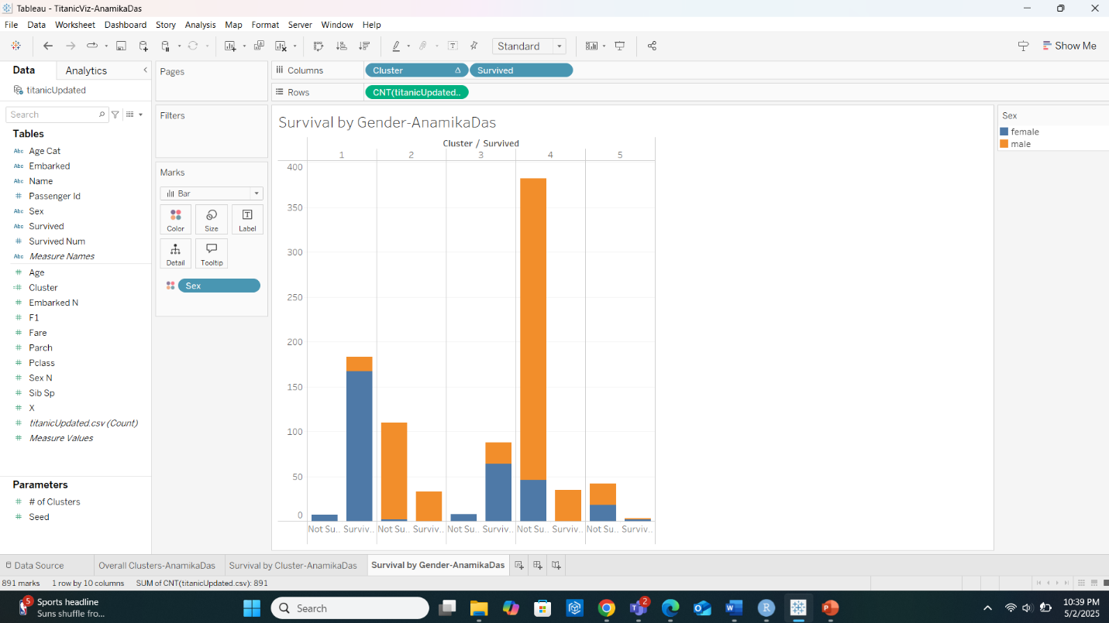

16. cluster 1.

17.
 | <Cluster 1> | <Cluster 3>
Ideal Gender | Female | Female
Ideal Passenger Class
Ideal Age Category
Ideal Embarked point
Ideal number of siblings

18.
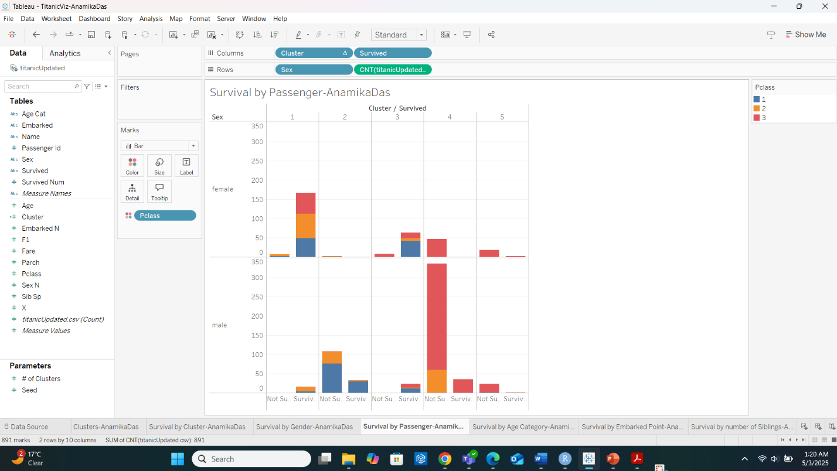

19.
 | <Cluster 1> | <Cluster 3>
Ideal Gender | Female | Female
Ideal Passenger Class | 2 | 1
Ideal Age Category
Ideal Embarked point
Ideal number of siblings

20.
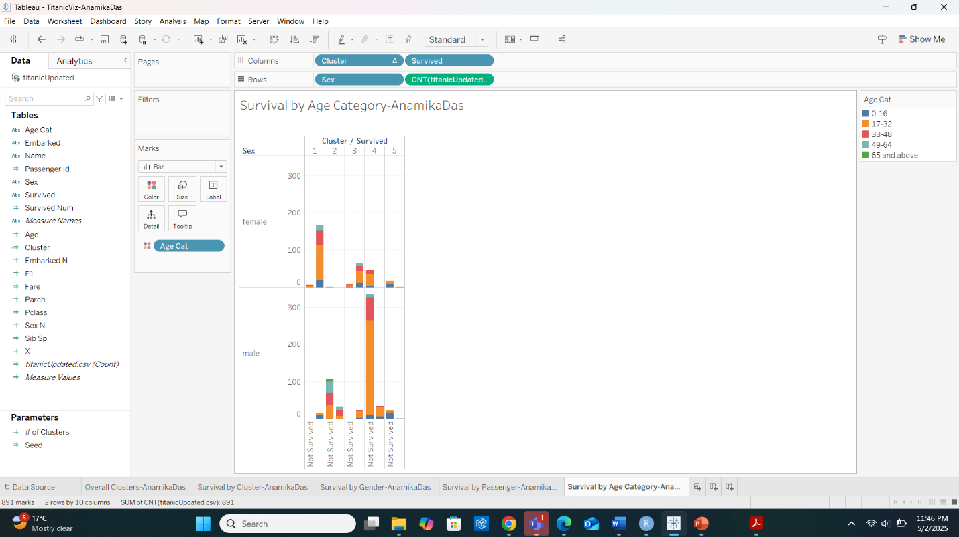

21.
 | <Cluster 1> | <Cluster 3>
Ideal Gender | Female | Female
Ideal Passenger Class | 2 | 1
Ideal Age Category | 17-32 | 17-32
Ideal Embarked point
Ideal number of siblings

22.
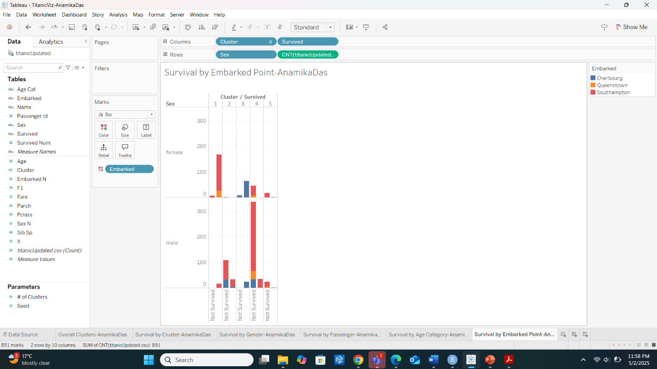

23.
 | <Cluster 1> | <Cluster 3>
Ideal Gender | Female | Female
Ideal Passenger Class | 2 | 1
Ideal Age Category | 17-32 | 17-32
Ideal Embarked point | southampton | cherbourg
Ideal number of siblings

24.
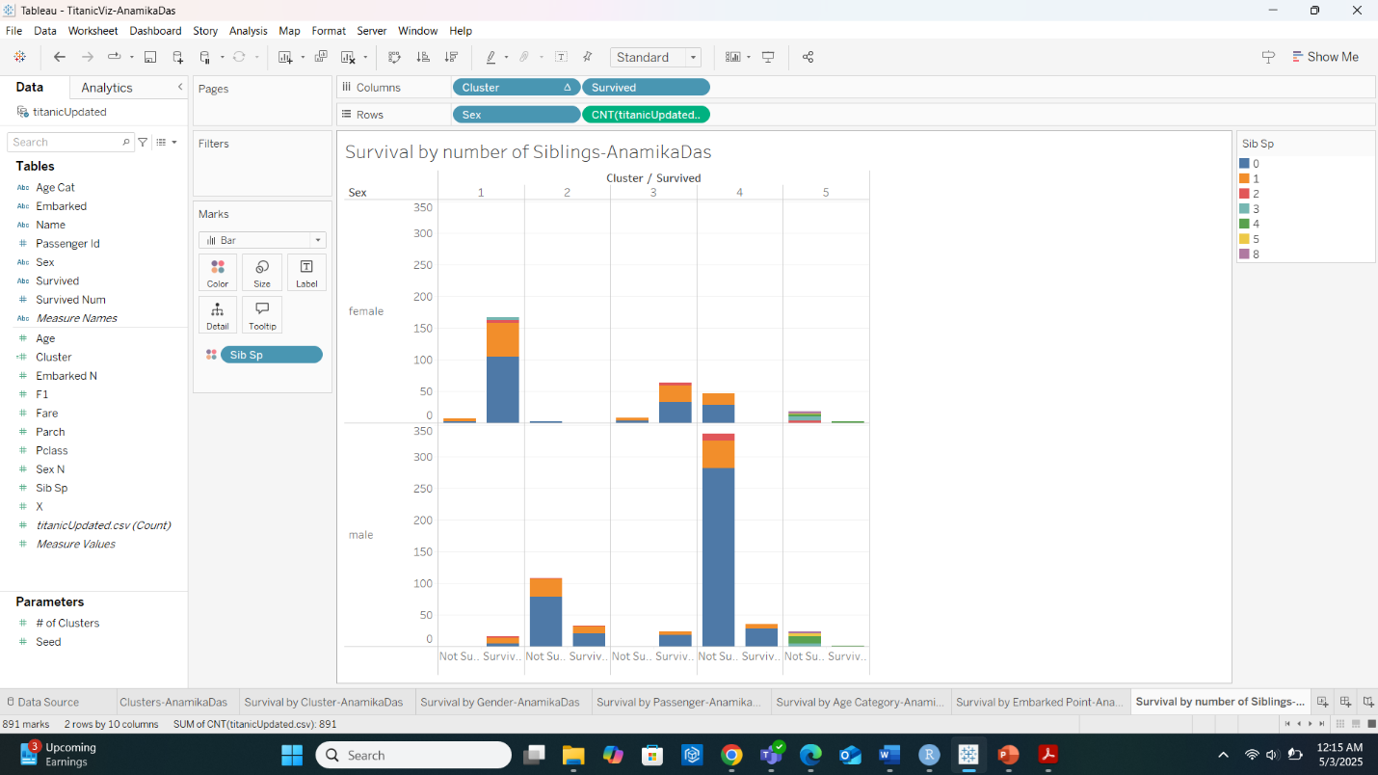
25.
 | <Cluster 1> | <Cluster 3>
Ideal Gender | Female | Female
Ideal Passenger Class | 2 | 1
Ideal Age Category | 17-32 | 17-32
Ideal Embarked point | southampton | cherbourg
Ideal number of siblings | 0 | 0

26.
Cluster 1:
Passengers in Cluster 1 who had the highest survivability were female, aged 17–32, traveling in 2nd class, with no siblings, and most commonly embarked from Southampton.
Cluster 3:
Survivors in Cluster 3 were predominantly female, aged 17–32, also in 1st class, with no siblings, and primarily embarked from Cherbourg.

